**EMPLOYEE DATABASE Analysis:**

**MySQL Queries for Project**

1. Create the Employee Table as per the below data in the table:

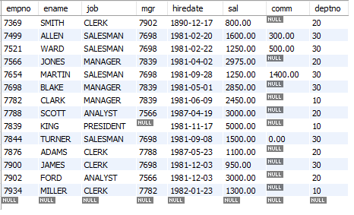

**Note :** Ensure the Salary is not less than zero

Empno cannot be null or Duplicate.

Default Job should be Clerk

1. List the Names and salary of the employees whose salary is greater than 1000
2. List Employee Names whose names start with either A or S.
3. List average monthly salary for each job within each department
4. Display the empno, Emp name and the Manager name under whom the Employee works.
5. Display Empname, department no, salary , Rank of salary in Organisation , Rank of Salary in their respective department